Department of Economics, Ethiraj College signed MoU with SICCI

The Postgraduate and Research Department of Economics and the Southern India Chamber of Commerce and Industry (SICCI) signed a Memorandum of Understanding to facilitate the industry academia collaboration on 29th August 2022.
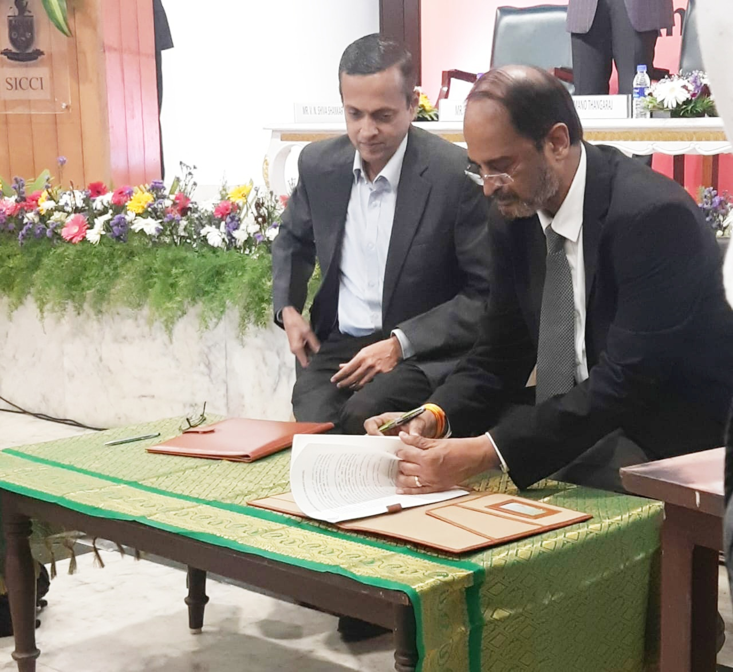
Thiru. V.M. Muralidharan, Chairman of Ethiraj College Trust and Mr. V.N. Shivashankar, Vice President of SICCI signing the MoU.

